**Navigation Drawer**

[Navigation Drawer](https://abhiandroid.com/materialdesign/navigation-drawer) is a panel that displays App’s Navigation option from the left edge of the screen. It is a uniform way to access different pages and information inside our app. It is hidden most of the time but is revealed when we swipes from left edge of the screen or whenever we click on menu/app icon in the action bar.

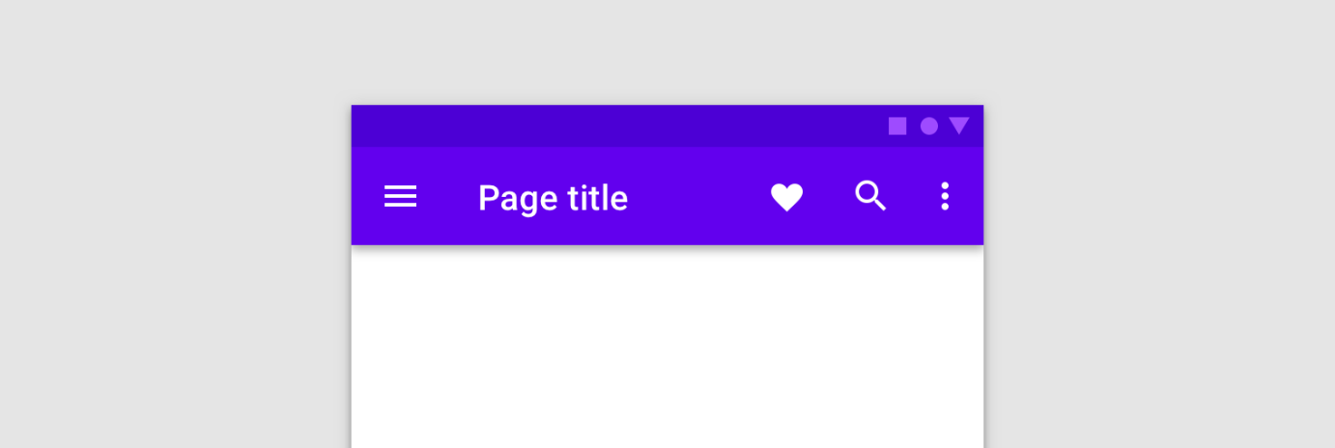

**Methods of Drawer Layout**

1. **closeDrawer(int gravity):** This method is used to close the drawer view by animating it into view. We can close a drawer by passing END gravity to this method.
2. **closeDrawers():** This method is used to close all the currently open drawer views by animating them out of view. We mainly use this method on click of any item of Navigation View.
3. **isDrawerOpen(int drawerGravity):**This method is used to check the drawer view is currently open or not. It returns true if the drawer view is open otherwise it returns false.
4. **openDrawer(int gravity):** This method is used to open the drawer view by animating it into view. We can open a Drawer by passing START gravity to this method.
5. **isDrawerVisible(int drawerGravity):**This method is used to check the drawer view is currently visible on screen or not. It returns true if the drawer view is visible otherwise it returns false.

**Methods of Navigation View**

1. **setNavigationItemSelectedListener(NavigationView.OnNavigationItemSelectedListener listener):**This method is used to set a listener that will be notified when a menu item is selected.
2. **setItemBackground(Drawable itemBackground):**This method is used to set the resource in the background of the menu item. In this method we pass the drawable object for setting background of menu item.
3. **setItemBackgroundResource(int resId):**This method is used to set the resource in the background of the menu item. In this method we pass the id of the resource to set in the background of menu item.
4. **getItemBackground():**This method returns the background drawable for our menu items.